- Open Outlook
- Go to calendar and double click.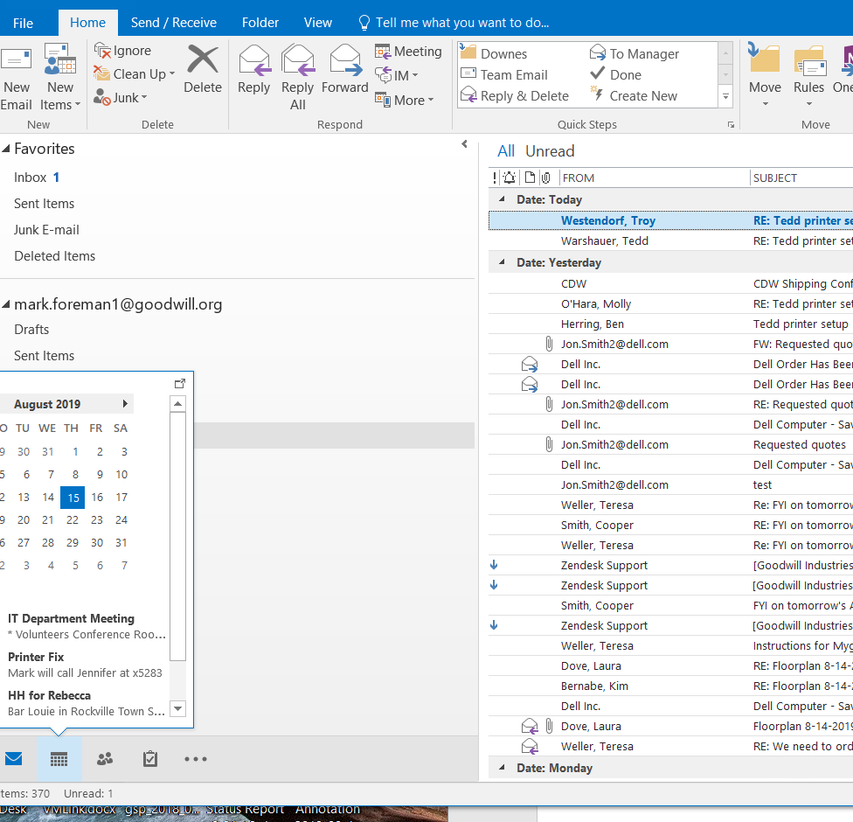

- Scroll down to Shared Calendar.

- Right click on Shared Calendars.
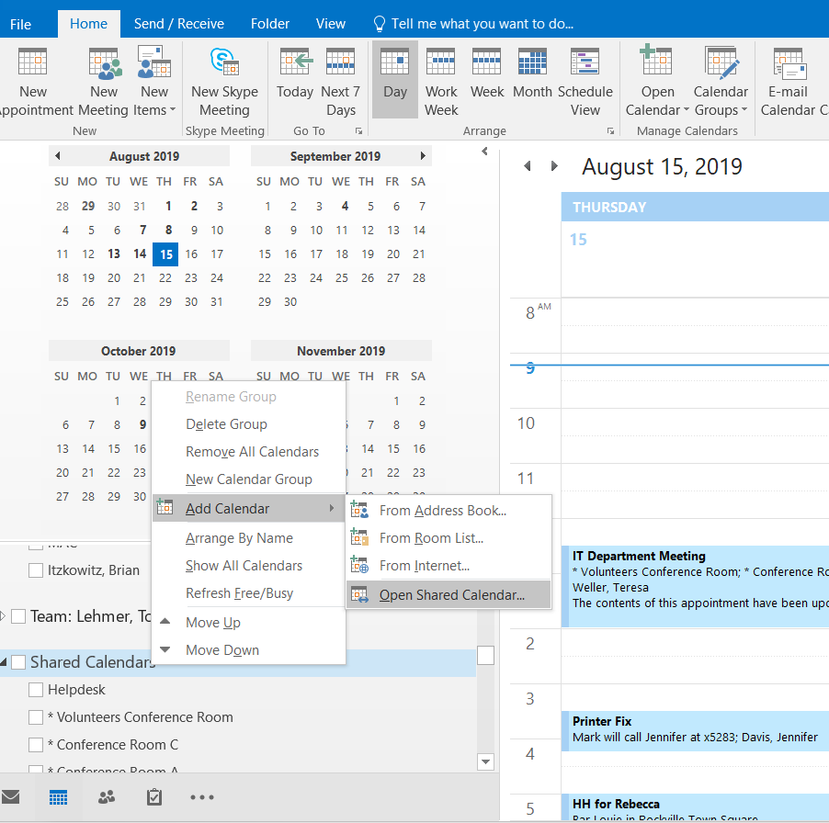

- Select Add Calendar then Open Shared Calendar
- Type in last name
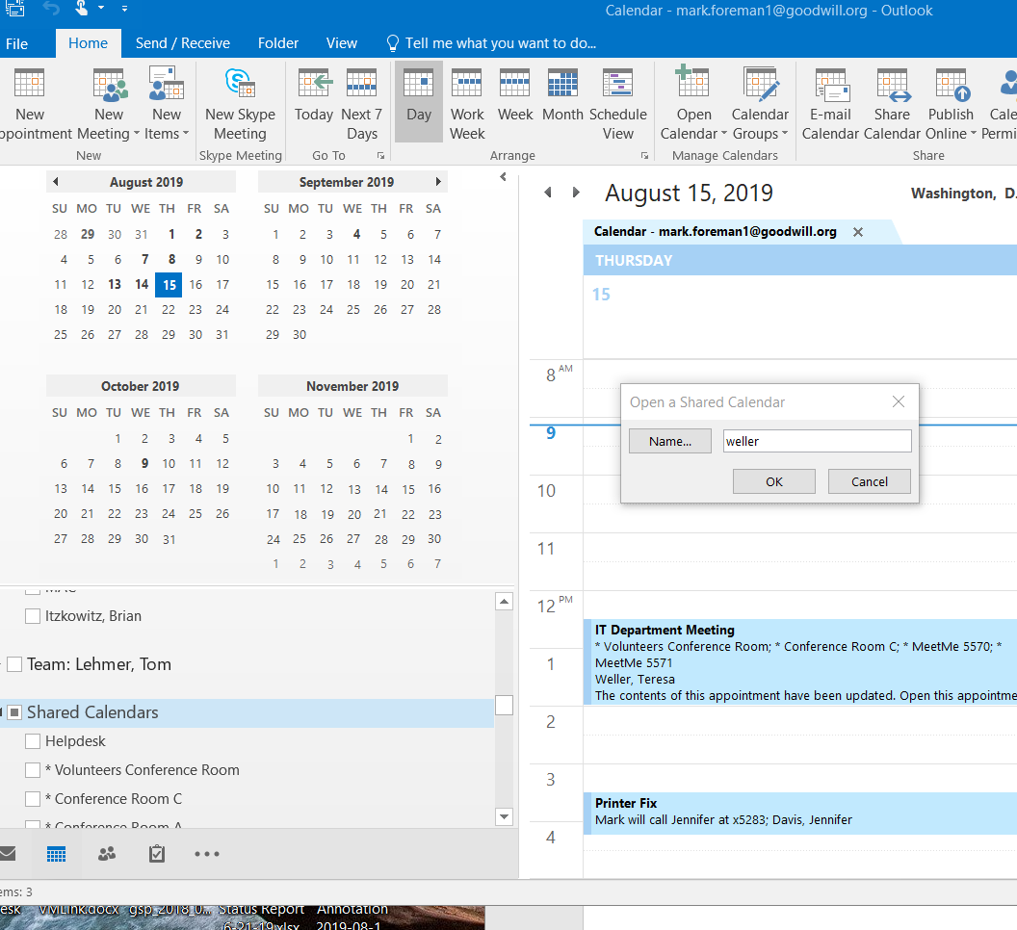

- Select ok.
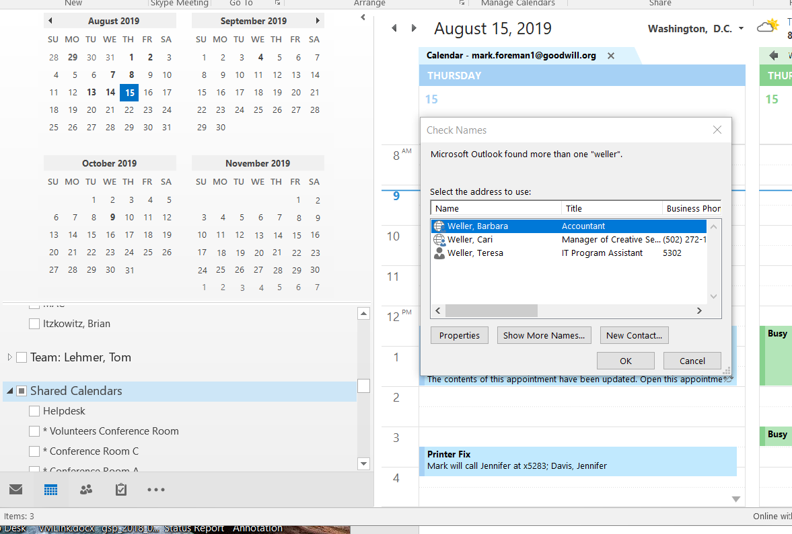

- Select user and click ok.
- User has now been added.

